

**Title**: The Hive Software Project Design Specification

**Version:** Final

**Approval Date:** 11/17/2013

**Approved By:** William Pegg

The Hive

Software Design Specification

Revision History

|  |  |  |
| --- | --- | --- |
| **Version number & date** | **Revised by** | **Description of changes** |
| Draft  010/19/13 | William Pegg | Initial draft |
| Draft  10/22/13 | William Pegg | Revised draft |
| Draft  11/13/13 | William Pegg | Revised draft |
| Final  11/17/13 | William Pegg | Revised draft – finalized SDS |

Table of Contents

Table of Figures 4

1. Introduction 5

1.1. Purpose 5

1.2. Scope 5

1.3. Definitions and Acronyms 6

2. References 6

3. Decomposition Description 7

3.1. General Structure 7

3.2. Object Oriented Approach 7

3.3.1 Use Case Diagram 7

3.3.2 ER Diagram 9

3.3.3 State Chart Diagram 11

4. Component Detail Design Description 13

4.1. Component 13

4.1.1 Structure 13

4.1.2 Function 15

4.1.3 Interfaces 15

4.1.5 Sequencing 23

4.1.6 Sequential Control Feature 27

4.1.7 Storage Allocation 27

4.1.8 Application Data 27

4.1.9 Detailed Design Descriptions 27

5. Quality Assurance 27

5.1. Test Cases 27

6. Preparation for Delivery 36

7. Appendices 36

# Table of Figures

Figure 1 – Definitions and Acronyms Chart…………………………………………………………………………………………6

Figure 2 – Use Case Diagram………………………………………………………………………………………………………………7

Figure 3 – Use Cases Chart…..…………………………………………………………………………………………………………….8

Figure 4 – ER Diagram…………………………… ………………………………………………………………………………………….9

Figure 5 – Component Overview Diagram…………………………………………………………………………………………10

Figure 6 – Pages Diagram……………………… …………………………………………………………………………………………11

Figure 7 – State Diagram – Manager/Admin User ……………………………………………………………….……………12

Figure 8 – State Diagram – Employee…….……………………………………………………………………………………….…13

Figure 9 – Structure Flow Chart – Manager/Admin User…….…….…………………………………………………….…14

Figure 10 – Structure Flow Chart – Employee……………….…….…….…………………………………………………….…15

Figure 11 – Program Interfaces…………………………………….…….…….…………………………………………………….…16

Figure 12 – Sequencing Diagram - Employee……………….…….…….……………….…………………………………….…24

Figure 13 – Sequencing Diagram – Manager/Administrator.…….…….………..…………………………………….…25

Figure 14 – Test Cases Chart……………………….……………….…….…….……………….…………………………………….…29

# Introduction

## Purpose

The purpose for the SDS document is to define the software that will meet the requirements stated previously in the SRS. The details of the design of the software program will be given as well as the test cases that were done on the program. Program code and design will be completed and given to client.

The Hive will be built with the purpose of giving SPSU students a website where they could have quick and easy access to different aspects of their group projects that are needed such as documentation, group communication, project progress, code and reports.

## Scope

The website we are designing will allow users to interact with the program.

They will be able to access the website through a browser and have access to a system application. Managers and group members will be able to manage documentation, group communication, project progress, code and reports. Administrators will access to everything on the website and employees will have access to the their groups and be able to see documentation, group communication, project progress, code and reports. Our application is designed to run on a sever to allow access to the website from any where the client has access to the internet.

## Definitions and Acronyms

|  |  |
| --- | --- |
| Term | Description |
| SDS | Software Design Specifications |
| SRS | Software Requirements Specifications |
| TBD | To be determined |
| OS | Operating system |
| SPSU | Southern Polytechnic State University |
| N/A  Figure 1. Definitions and Acronyms chart | Not Applicable |

# References

N/A

# Decomposition Description

## General Structure

The general structure of the software program is based on the database. All changes made using any interface of the software are connected and accessing the database at all times. All users that have access to The Hive website will be entering and retrieving information from the database.

## Object Oriented Approach

### 3.3.1 Use Case Diagram

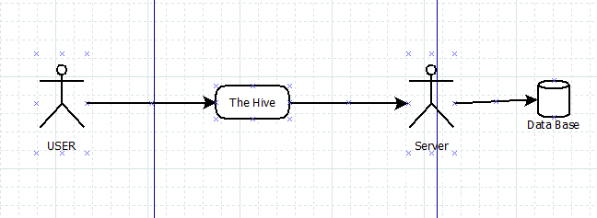

Figure 2. Use Case Diagram

|  |  |  |
| --- | --- | --- |
| Use Case ID | Use Case Name | Primary Actors |
| 2 | Log in | Student |
| 3 | Management home screen | Student |
| 4 | Completing posting | Student |
| 5 | Approving an entry (if needed) | Group manager |
| 6 | Creating new Category | Group manager |
| 7 | Adding a new Account | Group manager |
| 8 | Changing Password | Student |
| 9 | Deleted posts | Group manager |
| 11 | Reports | Student |
| 12 | Users - adding | Website app |
| 13 | Users - Manage Users | Website app |

Figure 3. Use Cases Chart

### 3.3.2 ER Diagram

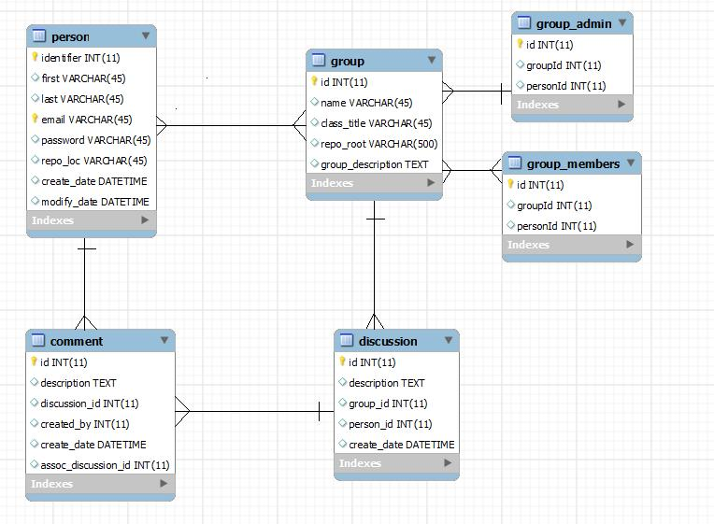

Figure 4. ER Diagram

### 

Figure 5. Component Overview Diagram

### 3.3.3 State Chart Diagram

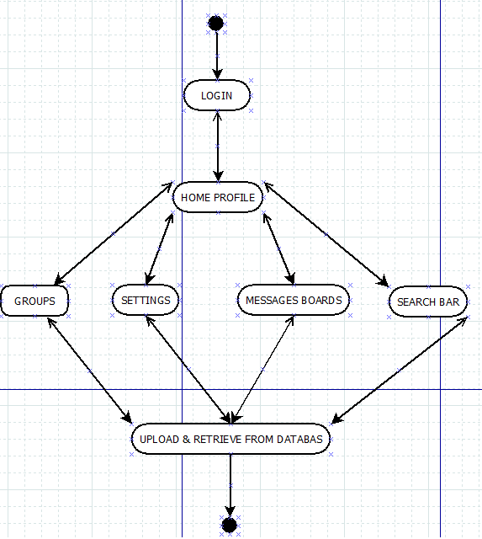

Figure 8. State Diagram – Employee

# Component Detail Design Description

## Component

### 4.1.1 Structure

**The HIVE Web application**

**Profile**

**Search**

**N/A**

**Database**

**Log in**

**Settings**

**F.A.Q**

**Repo**

**Boards**

Figure 9. Structure Flow Chart - Manager / Admin User

**The HIVE Web application**

**Groups**

**Search**

**REPO**

**Database**

**Log in**

Figure 10. Structure Flow Chart – Employee

### 4.1.2 Function

The program functions by allowing student to use The Hive in order to keep track of groups, messages, documents, group members, and group files. The program will give managers and administrative users access to all aspects of the application. Regular members of a group will only have access to the documents, messages, and group files.

### 4.1.3 Interfaces

**Login Page**

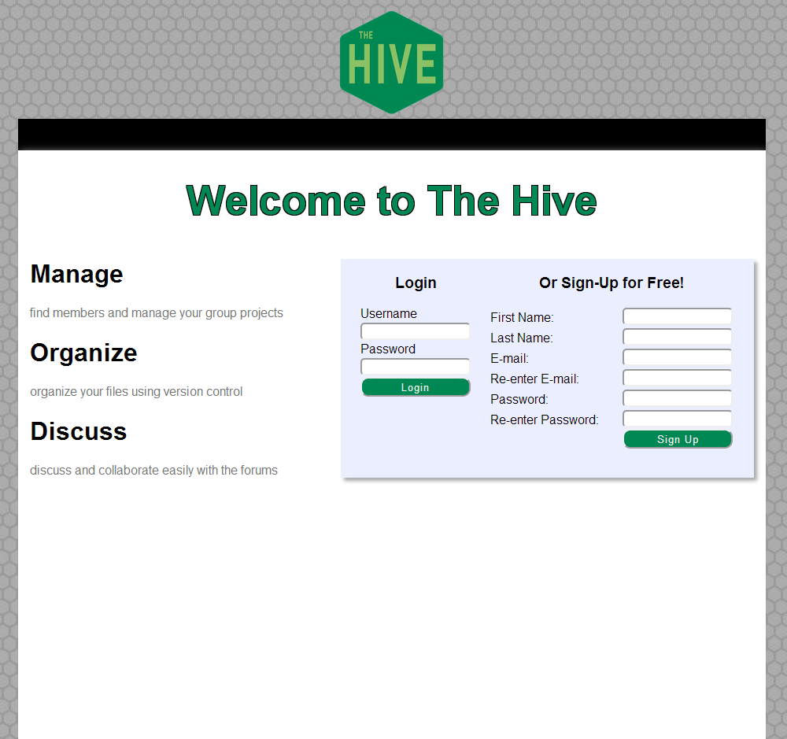

**Profile Page**

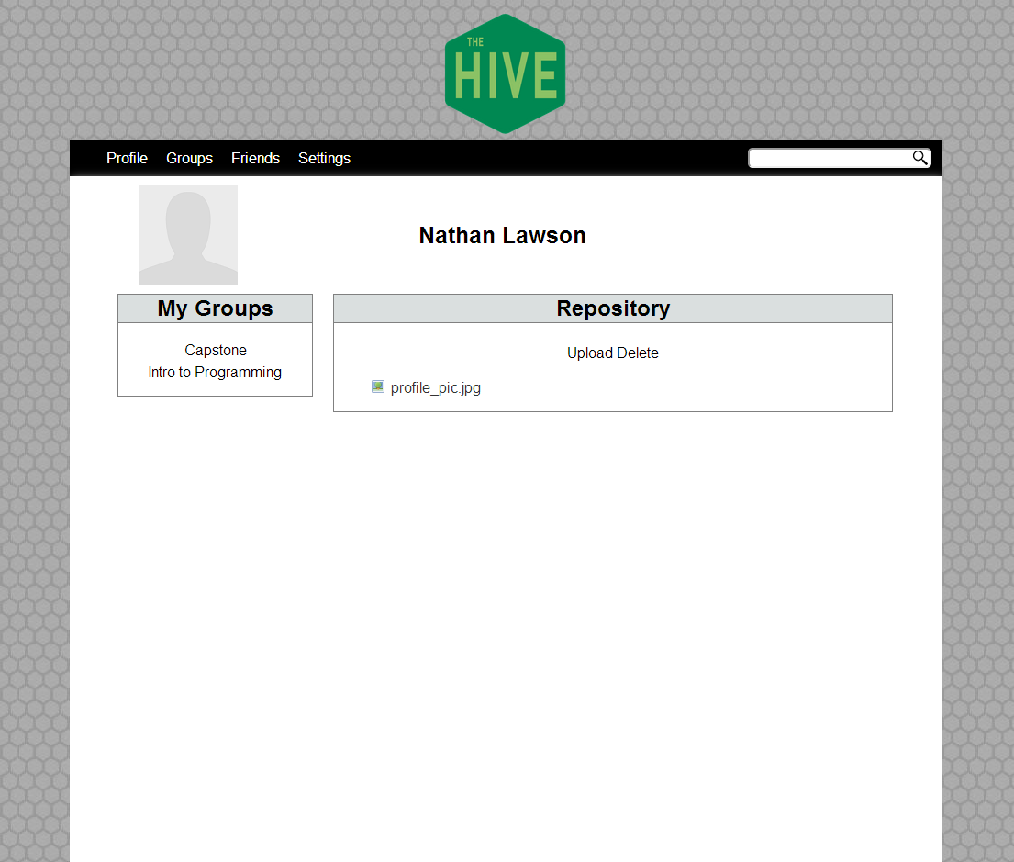

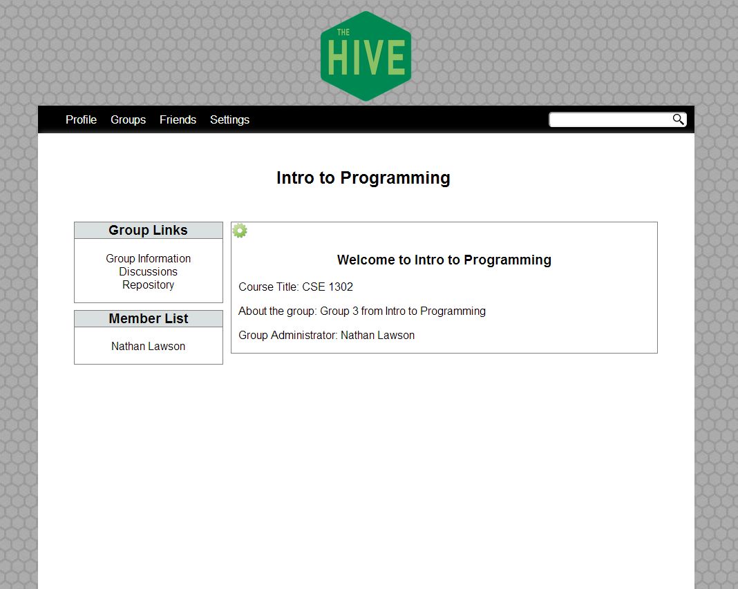

**Groups Page**

**Search Page**

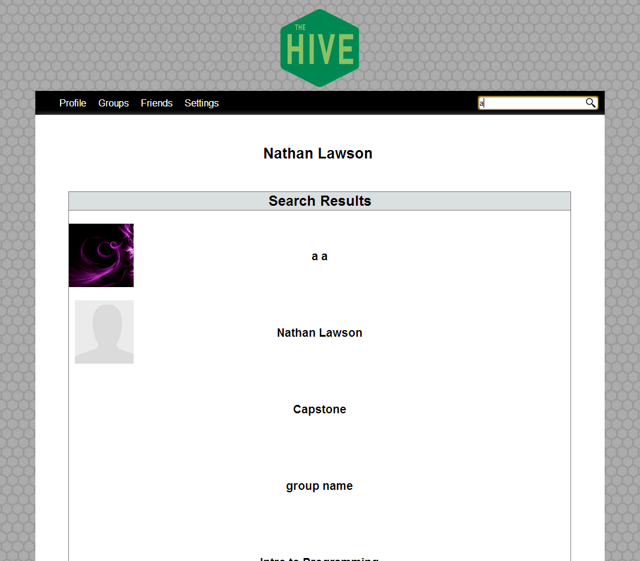

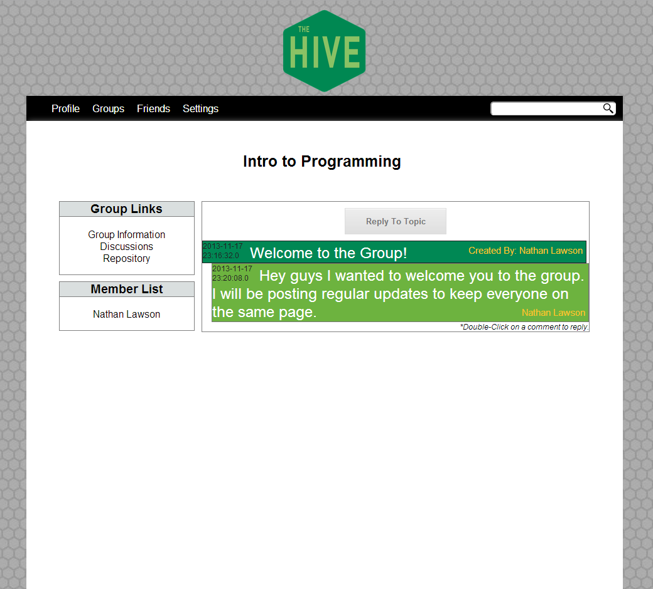

**Boards Page**

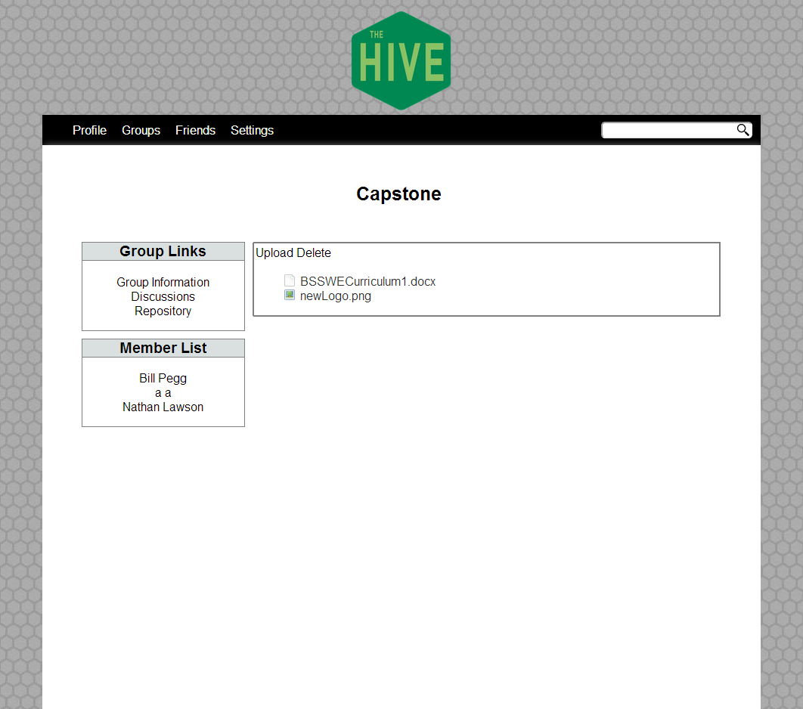

**REPO. Page**

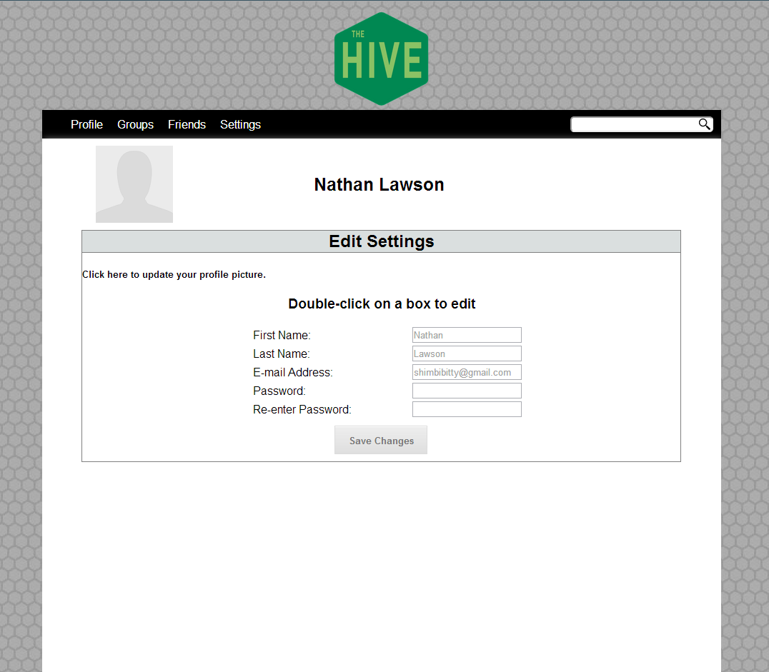

**Settings Page**

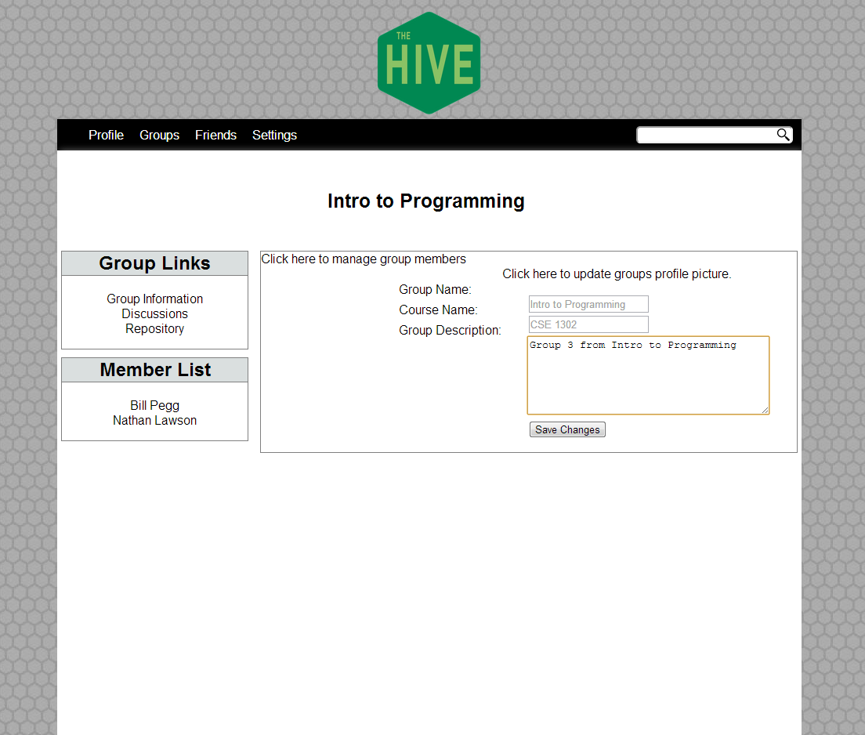

**Manage Users Page**

Figure 11. Program Interfaces

### 4.1.5 Sequencing

### 4.1.6 Sequential Control Feature

After arriving at The Hive web application, both the manager / regular users and will have to login to gain access to the system. Users with no credentials will not have access to the system. Users will have access to view documentation, group communication, project progress, code and reports. Managers and admin users will have access to all pages on the system.

### **4.1.7 Storage Allocation**

### All storage allocation will be done using the database.

### 4.1.8 Application Data

All application data will be stored and retrieved from the database.

### 4.1.9 Detailed Design Descriptions

The Hive is a website that requires student credentials in order to be able to use the services. Users that visit the site but do not have valid credentials will not be able to enter the system. The website will be accessible through any OS and a web browser, and will have a ribbon across the top of the application to make navigation through all pages easy and quick.

Group Managers users will be able to log in to the system and view all the different pages of the system. They will have rights to add, delete, and post message entries. Regular users will have access to view the documents, the messages, and the file page. They will not be able delete anything on the site, but they will be able to add entries and send them to only the groups that they are in.

# Quality Assurance

## Test Cases

|  |  |  |  |  |  |
| --- | --- | --- | --- | --- | --- |
| Test Case | Test Steps | Expected Results | Transaction name | Pass | Fail |
|  | Enter correct user name and password | Login successful / user taken to home page | User Login |  |  |
|  | Enter correct user name and incorrect password | Login failed / return message: incorrect user name or password | User Login |  |  |
|  | Enter incorrect username and incorrect password | Login failed / return message: incorrect user name or password | User Login |  |  |
|  | 3 incorrect logins | Login failed / return message: exceeded 3 login attempts | User Login |  |  |
|  | Enter incorrect username and correct password | Login failed / return message: incorrect user name or password | User Login |  |  |
|  | Logout tab selected | brought to login page | Logout |  |  |
|  | Change password tab selected | Change password form displayed | Password change |  |  |
|  | Enters new password and enters matching password in the confirm field | Password change successful | Password change |  |  |
|  | Enters new password under 8 digits | Password change failed / return message: password needs at least 8 digits | Password change |  |  |
|  | Enters new password and enters a mismatching password in the confirm field | Password change failed / return message: passwords do not match | Password change |  |  |
|  | Leave both fields blank | Password change failed / return message: password required | Password change |  |  |
|  | Enters username, matching passwords and assigns role manger | New user added successfully | Add user |  |  |
|  | Enters username, matching passwords and assigns role employee | New user added successfully | Add user |  |  |
|  | Enter mismatching passwords | New user failed / return message: passwords do not match | Add user |  |  |
|  | Enter password under 8 digits | New user failed / return message: password must be at least 8 digits | Add user |  |  |
|  | Fail to assign role | New user failed / return message: must choose a role | Add user |  |  |
|  | All fields left blank | New user failed / return message: username required | Add user |  |  |
|  | Enter username, password left blank | New user failed / return message: password required | Add user |  |  |
|  | Username left blank | User edit failed / return message: username required | Edit user |  |  |
|  | Enter password under 8 digits | User edit failed / return message: password must be at least 8 digits | Edit user |  |  |
|  | Enter mismatching passwords | User edit failed / return message: passwords do not match | Edit user |  |  |
|  | Enter updated user info | User edit successful | Edit user |  |  |
|  | Active user tab selected on vertical users menu | Active users displayed | Manage users |  |  |
|  | Inactive user tab selected on vertical users menu | Inactive users displayed | Manage users |  |  |
|  | Activate search tab selected for inactive user | Selected user is now displayed as active | Manage users |  |  |
|  | Inactivate search tab selected for active user | Selected user is now displayed as inactive | Manage users |  |  |
|  | Attempt login with inactive user | Login failed / return message: incorrect user name or password | Manage users / Access Control |  |  |
|  | Edit search tab selected for active user | Edit user form displayed | Manage users |  |  |
|  | Account tab selected on vertical accounts menu tab | Accounts are displayed | Manage Accounts |  |  |
|  | Add new account tab selected on vertical account menu tab | Add new account form displayed | Manage Accounts |  |  |
|  | Enter name, description | Search result(s) matching account name displayed | Account Search |  |  |
|  | Enter name, description | Search result(s) matching account name displayed | Account Search |  |  |
|  | Name blank | Search result(s) matching account description displayed | Account Search |  |  |
|  | Name blank, enter description, any user, any category | Search result(s) matching account description displayed | Account Search |  |  |
|  | Account search by category | Search result(s) matching appropriate account category displayed | Account Search |  |  |
|  | Account search by user | Search result(s) matching appropriate user displayed | Account Search |  |  |
|  | Account search for not deleted | Appropriate search result(s) displayed | Account Search |  |  |
|  | Account search for deleted | Appropriate search result(s) displayed | Account Search |  |  |
|  | Edit tab selected for account on search result | Edit account form displayed | Manage Accounts |  |  |
|  | Delete tab selected for account on search result | Account add to deleted accounts | Manage accounts |  |  |
|  | Account name left blank | Add new account failed / return message: name required | Add Account |  |  |
|  | Account description left blank | Add new account failed / return message: description required | Add Account |  |  |
|  | left blank | Add new account failed / return message: required | Add Account |  |  |
|  | Account left blank | Add new account failed / return message: account required | Add Account |  |  |
|  | not selected | Add new account failed / return message: required | Add Account |  |  |
|  | Category not selected | Add new account failed / return message: category required | Add Account |  |  |
|  | Type not selected | Add new account failed / return message: type required | Add Account |  |  |
|  | All appropriate information entered | Add account successful | Add Account |  |  |
|  | Category name left blank | Add new category failed / return message: name required | Add Category |  |  |
|  | Category description left blank | Add new category failed / return message: description required | Add Category |  |  |
|  | All appropriate information entered | Add new category successful | Add Category |  |  |
|  | Categories tab selected on vertical category menu tab | Manage categories page displayed | Manage Categories |  |  |
|  | Add new category tab selected on vertical category menu tab | Add new category form displayed | Manage Categories |  |  |
|  | Show deleted categories tab selected on vertical categories menu tab | Deleted categories displayed | Manage Categories |  |  |
|  | Show regular categories tab selected on vertical categories menu tab | Regular categories displayed | Manage Categories |  |  |
|  | Edit tab selected for category under regular categories | Edit category form displayed | Manage Categories |  |  |
|  | Delete tab selected for category under regular categories | Category moved to deleted categories | Manage Categories |  |  |
|  | Undelete tab selected for category under deleted categories | Category moved to regular categories | Manage Categories |  |  |
|  | Home tab selected on horizontal menu | Home page displayed | Home - Horizontal Menu |  |  |
|  | Categories tab selected on horizontal category dropdown tab | Manage categories page displayed | Categories - Horizontal Menu |  |  |
|  | Add new category tab selected on horizontal category dropdown tab | Add new category form displayed | Categories - Horizontal Menu |  |  |
|  | Account tab selected on horizontal account dropdown tab | Manage accounts page displayed | Accounts - Horizontal Menu |  |  |
|  | Add new account tab selected on horizontal account dropdown tab | Add new account form displayed | Accounts - Horizontal Menu |  |  |
|  | Users tab selected on horizontal users dropdown tab | Manage users page displayed | Users - Horizontal Menu |  |  |
|  | FAQs tab selected on horizontal menu | FAQs page displayed | FAQs - Horizontal Menu |  |  |
|  | FAQs category selected | Section expands to display information | FAQS Page Navigation |  |  |
|  | Employee type page user section into address bar | View page failed / return message: access denied | Access Control |  |  |
|  | Employee type page category section into address bar | View page failed / return message: access denied | Access Control |  |  |
|  | Student type page account section into address bar | View page failed / return message: access denied | Access Control |  |  |
|  | Student logged in | Employee posts should not be displayed | Access Control |  |  |
|  | Student logged in | Employee delete posts should not be displayed | Access Control |  |  |
|  | Student logged in | Student undelete entry should not display for deleted category | Access Control |  |  |
|  | Student logged in | Student user section should not display on menu | Access Control |  |  |
|  | Student logged in | Student account section should not display on menu | Access Control |  |  |
|  | Student logged in | Student reports should not display | Access Control |  |  |
|  | Student logged in | Student categories should not display | Access Control |  |  |

Figure 14. Test Cases Chart

**Testing phase 1: Number of tests failed: #failed/total Testing phase 2: Number of tests failed:**

**Percent passed:**

# Preparation for Delivery

We are rigorously testing all information and aspects of the software to ensure that the product will be fast and as user friendly as possible. Also, this will ensure that the product is ready by the expected delivery date and under the budget allocated.

# Appendices

N/A